**Style Transfer**

**Latest Submission Grade 100%**

**1.**

**Question 1**

In Neural Style Transfer when initializing the *generated image* from the *content image,*which of the following is true? Check all that apply.

**1 / 1 point**



Initially the *style loss* will be equal or close to zero because both, the *content* and *generated*, images are the same.



Initially the *content loss* will be equal or close to zero because both the *content image* and *generated* image are the same image.

**Correct**

Correct!



Your goal for the *generated image* is to increase the *content loss* and decrease the *style loss*, while keeping the overall *accumulated loss* low.

**Correct**

Correct! Since the *generated image* is initialized from the *content image*, you want it to inherit attributes from the *style image* (reduce *style loss*), but also not lose all of its attributes inherited from the *content image* (increase *content loss*).



Your goal for the *generated image* is to increase the *style loss* and decrease the *content loss* while keeping the overall *accumulated loss* low.

**2.**

**Question 2**

What does tf.keras.applications.vgg19.preprocess_input do?

**1 / 1 point**



The function centers the distribution of pixel values of an image around zero.



The function sets the pixel values of an image between 0 and 1.

**Correct**

Correct! This is called standardization.

**3.**

**Question 3**

From which part of a CNN architecture can you extract the “content” of an image?

**1 / 1 point**



From the deeper layers of the architecture.



The initial layers of the architecture.

**Correct**

Correct! If you recall the lecture we used only the deeper layer of the CNN for computing *content loss* because that layer holds the information of the *content* of an image.

**4.**

**Question 4**

Consider the values given in the image below and calculate the *content loss* value.

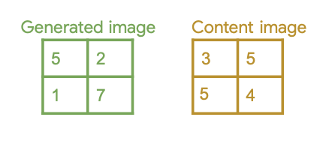

**1 / 1 point**

19

**Correct**

Correct!

**5.**

**Question 5**

Fill in the missing code below:

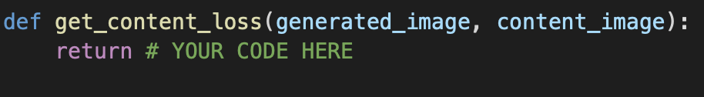

**1 / 1 point**



0.5 * tf.reduce_sum(tf.square(content_image - generated_image))

**Correct**

Correct! Even though the original formula is *generated_image - content_image*, since you are *squaring* the difference it doesn’t matter what you subtract out of what.



0.5 * tf.reduce_sum(tf.square(generated_image - content_image))

**Correct**

Correct!

**6.**

**Question 6**

Consider the following code snippet. How will you include *Total Loss Variation* in it? Use TensorFlow as *tf.*

(Answer in the format, **x + y(z)**, considering python’s spacing convention)

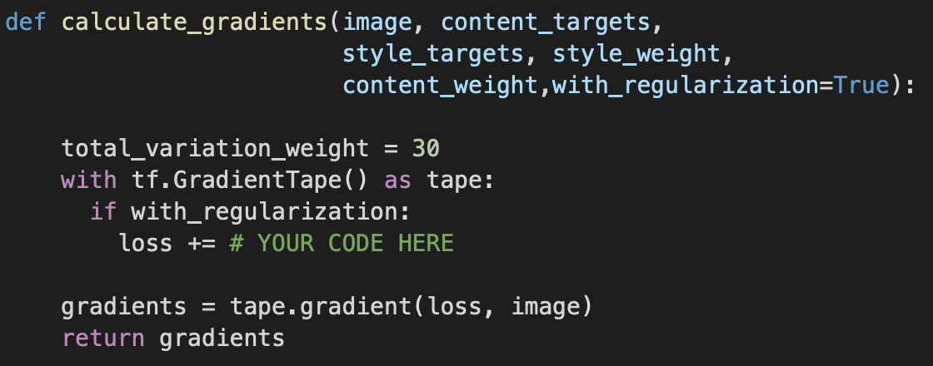

**1 / 1 point**

total_variation_weight * tf.image.total_variation(image)

**Correct**

C​orrect!